english

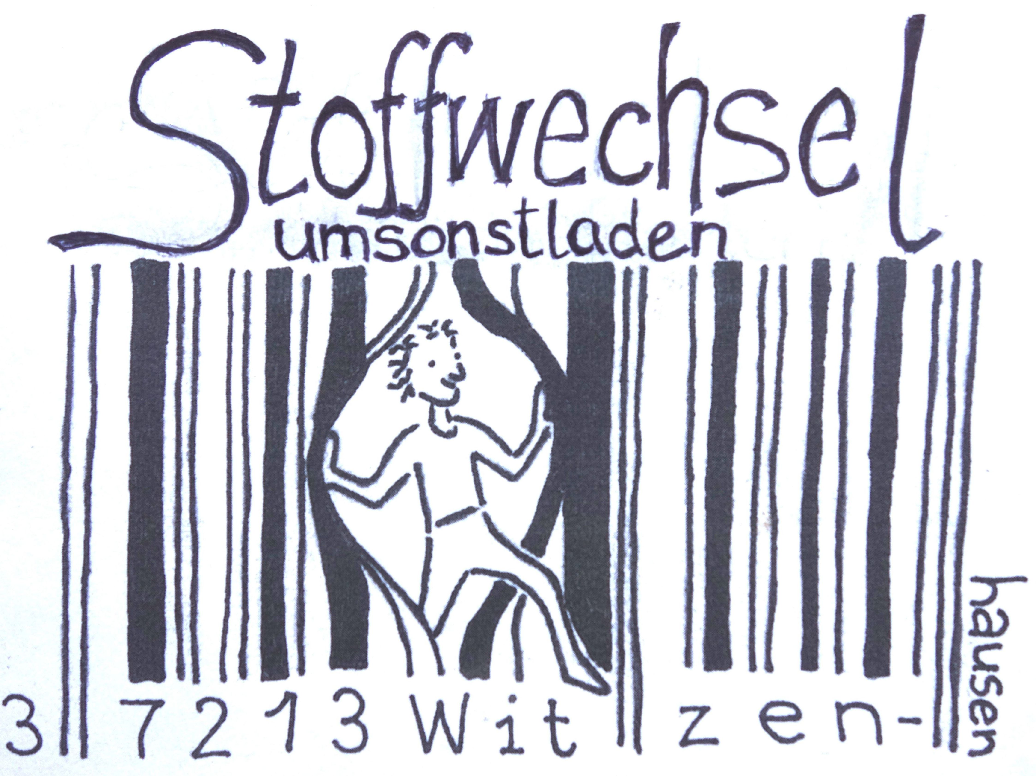

**Opening times:**

http://u-la.de

or have a look at our shop door

**Contact:**

Brückenstraße 18

37213 Witzenhausen

[info@u-la.de](mailto:info@u-la.de)

**Website:**

<http://u-la.de>

**Donation:**

account holder: Frieda and Manuel Petermann

Iban: DE59 4306 0967 4073 6653 00

BIC: GENODEM1GLS

Keyword: Stoffwechsel

english



**Opening times:**

http://u-la.de

or have a look at our shop door

**Contact:**

Brückenstraße 18

37213 Witzenhausen

[info@u-la.de](mailto:info@u-la.de)

**Website:**

<http://u-la.de>

**Donation:**

account holder: Frieda and Manuel Petermann

Iban: DE59 4306 0967 4073 6653 00

BIC: GENODEM1GLS

Keyword: Stoffwechsel

**How it works:**

You can bring things you would give to someone as a

present. For example:

books, clothes (no underwear), shoes, games, dishes,...

**No broken, dirty' or unusable things please!**

Large things like furniture can be offered at our pin

board or see our webpage http://ula.de for online

gift economy links.

Goods are only accepted during our opening times,

please don´ t leave

them in front of the door!

**No money involved?**

To give and to receive itself works without money but

we have to pay for running the shop monthly: 293 Euro

for rent, gas and power.

We are happy about money donations for that.

Therefore any donations are welcome!

Umsonstladen-Team members don´ t receive any

money for their work, they are volunteers.

**How it works:**

You can bring things you would give to someone as a

present. For example:

books, clothes (no underwear), shoes, games, dishes,...

**No broken, dirty' or unusable things please!**

Large things like furniture can be offered at our pin

board or see our webpage http://ula.de for online

gift economy links.

Goods are only accepted during our opening times,

please don´ t leave

them in front of the door!

**No money involved?**

To give and to receive itself works without money but

we have to pay for running the shop monthly: 293 Euro

for rent, gas and power.

We are happy about money donations for that.

Therefore any donations are welcome!

Umsonstladen-Team members don´ t receive any

money for their work, they are volunteers.

**Umsonstladen – what does it mean?**

You can donate things which lost the meaning for

yourself but are still intact and useful for others to

Umsonstladen to forward it as a gift to someone who

needs them.

At the same time you can take things with you which

are useful for yourself.

Although to give, to take or to donate are not

necessari ly related.

Low prices are a result of Overproduction and that

misguides humanity to just throw away precious

things that we the people take for granted.

Resources become scarce, mountains of rubbish grow,

people in other countries work under the most

indecent conditions for us to buy a lot

very cheap.

With critical consumption we try to avoid taking

part in the throwaway society.

We ask ourselves what we really need before we take

something. We live and consume on the principle:

**Using instead of possessing!**

**Umsonstladen – what does it mean?**

You can donate things which lost the meaning for

yourself but are still intact and useful for others to

Umsonstladen to forward it as a gift to someone who

needs them.

At the same time you can take things with you which

are useful for yourself.

Although to give, to take or to donate are not

necessari ly related.

Low prices are a result of Overproduction and that

misguides humanity to just throw away precious

things that we the people take for granted.

Resources become scarce, mountains of rubbish grow,

people in other countries work under the most

indecent conditions for us to buy a lot

very cheap.

With critical consumption we try to avoid taking

part in the throwaway society.

We ask ourselves what we really need before we take

something. We live and consume on the principle:

**Using instead of possessing!**